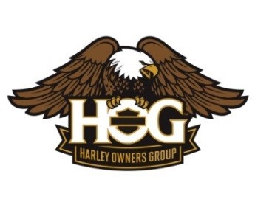
Worcester H.O.G. Chapter #3811
New England Yankee Run Book
“The Orange FUN Book”
Information & Application

Dear Prospective Stop Customer

The Yankee Run program has provided riders and businesses with a way to connect since 1994 through our annual New England Yankee Run Book, which provides destinations all over New England. You are being contacted because we have visited your business, or a fellow rider has suggested it, and thought your establishment would be a great addition to our tour stop book.

Some of our sponsors have been with us from the beginning and they include restaurants, cafés, general stores, country stores, farm stands, ice cream shops, etc. The cost to you as a sponsor is just $30 per year!
How it works
When a book holder comes in and makes a purchase, all you need to do is stamp or sign the book in your designated space. You have the right to refuse to sign if no purchase is made and
there are no discounts involved with this book.
We print 300 copies per year and the sales of Yankee Run Books has averaged sale of 215 per year (potential customers for you). The program runs from April through November

ONE PERSON ONE BOOK ONE PURCHASE ONE STAMP
We, the Worcester Harley Owners Group New England Yankee Run Committee, would love to have you join us! An application is on the back for you to submit with your $30 application fee, which
We need to receive it by February 26, 2027 (details below).

We understand that you may have questions and look forward to the opportunity to speak with you at your convenience. You may contact us by phone or email (yankeerun@worcesterhog.com). Please put “Yankee Run” in the subject line if using email.
If we don’t hear from you, we may follow up with a phone call over the next few months. We are in the process of putting together our Yankee Run Book for 2027 and hope that you will be a part of it!

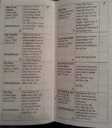
Very truly yours,

The Yankee Run Committee
Email : yankeerun@worcesterhog.com
George Gilligan : (508) 763-8463

Please make checks payable to:
“Worcester H.O.G Yankee Run”

Mail your application to:
Sheldon’s Harley-Davidson
c/o Worcester H.O.G. Yankee Run
914 Southbridge Street
Auburn, MA 01501
2027 New England Yankee Run Application

I would like to participate in the Yankee Run Book for 2027. My completion of this form is my authorization for the below information to be included in the book for (1) year. *
Please send Check in by February 26, 2027
.
Name/Address of Business/Description

Name of Business _____________________________________________________________

Mailing Address ________________________________________________________________

Business Address_________________________________________________________________

Town ______________________________ St _____________ Zip _______________

Who is the contact _______________________________ Phone #_________________________

Business E-mail ______________________________________________________________
Specialties / highlights of your business (information for your book entry):
Website: ________________________________________________
Social media: ______________________________do you participate on Messenger

Business Description____________________________________________________________
_________________________________________________________________________
_________________________________________________________________________
Hours of Operation:
_________________________________________________________________________
Directions (please include RT # if applicable):
_________________________________________________________________________
_________________________________________________________________________
_________________________________________________________________________

Contact information (so we can stay in touch with you Off Season /next year):
Owner’s Name: _____________________________________
Send Check for $30
Please make checks payable to:
“Worcester H.O.G Yankee Run”

Mail your application to:
Sheldon’s Harley-Davidson
c/o Worcester H.O.G. Yankee Run
914 Southbridge Street
Auburn, MA 01501
Owner’s Phone: _____________________________________
Email: _____________________________________
Mailing Address Off Season:
(if different from Business Address)
__________________________________________________
__________________________________________________

